

User manual eVoterMobile 1.0

Bui Thi Diem

Nguyen Van Luong

Nguyen Thi Mai

Contents

TOC \o 2-3 \t "Heading, 4"

1.0 General information PAGEREF _Toc \h 3

2.0 System summary PAGEREF _Toc1 \h 3

2.1 System configuration PAGEREF _Toc2 \h 3

2.2 User access level PAGEREF _Toc3 \h 3

2.3 Contingencies PAGEREF _Toc4 \h 3

3.0 Getting started PAGEREF _Toc5 \h 4

3.0 Install PAGEREF _Toc6 \h 4

3.1 Login PAGEREF _Toc7 \h 5

3.2 Register PAGEREF _Toc8 \h 6

3.2.1 Valid input data PAGEREF _Toc9 \h 6

3.2.2 User exists PAGEREF _Toc10 \h 7

3.2.3 Register successfully PAGEREF _Toc11 \h 8

3.3. Reset password PAGEREF _Toc12 \h 8

3.3.1 Request reset password PAGEREF _Toc13 \h 9

3.3.2 Reset password successful PAGEREF _Toc14 \h 9

4.0 Using the eVoterMobile PAGEREF _Toc15 \h 10

4.1 List subject PAGEREF _Toc16 \h 10

4.2 List session PAGEREF _Toc17 \h 11

4.2 List User of Subject PAGEREF _Toc18 \h 12

4.3. New Session PAGEREF _Toc19 \h 12

4.1.3 View detail a subject PAGEREF _Toc20 \h 13

4.1.4 Create a new subject PAGEREF _Toc21 \h 14

4.2 Teacher tab PAGEREF _Toc22 \h 15

4.2.1 Edit a teacher's information PAGEREF _Toc23 \h 15

4.2.2 Delete a teacher PAGEREF _Toc24 \h 16

4.2.3 View a teacher's information PAGEREF _Toc25 \h 16

4.2.4 Create a new teacher PAGEREF _Toc26 \h 17

4.3 Student tab PAGEREF _Toc27 \h 17

4.3.1 Edit a student's information PAGEREF _Toc28 \h 17

4.3.2 Delete a student PAGEREF _Toc29 \h 18

4.3.3 View a student's information PAGEREF _Toc30 \h 18

4.3.4 Create a new student PAGEREF _Toc31 \h 19

# 1.0 General information

eVoterMobile is an Android application which support for teacher and student in classroom.

Student can user eVoterMobile to join a session, vote for session and answer the question which teacher has asked them during the session running time.

Teacher can user eVoterMobile to create new session, edit a his session, create question and send question to student during the session running time.

# 2.0 System summary

## 2.1 System configuration

Devices support: Android 2.3 to Android 4.4

The application requires connection to internet in order to connect to server, and get and save data to database.

## 2.2 User access level

The functionality of eVoterMobile depend on type of user. A teacher user has more functionality than a student user.

## 2.3 Contingencies

In case there is Internet connection, user cannot login and use system.

# 3.0 Getting started

## 3.0 Install

Download link: [https://www.dropbox.com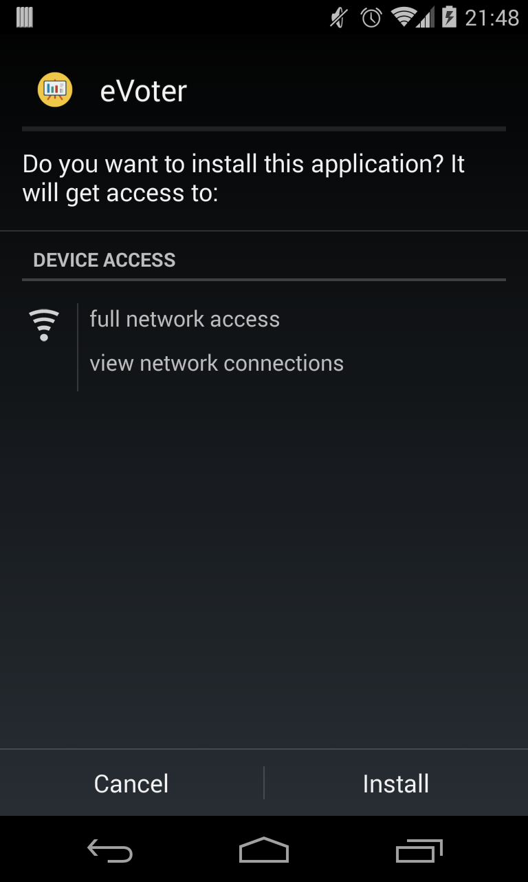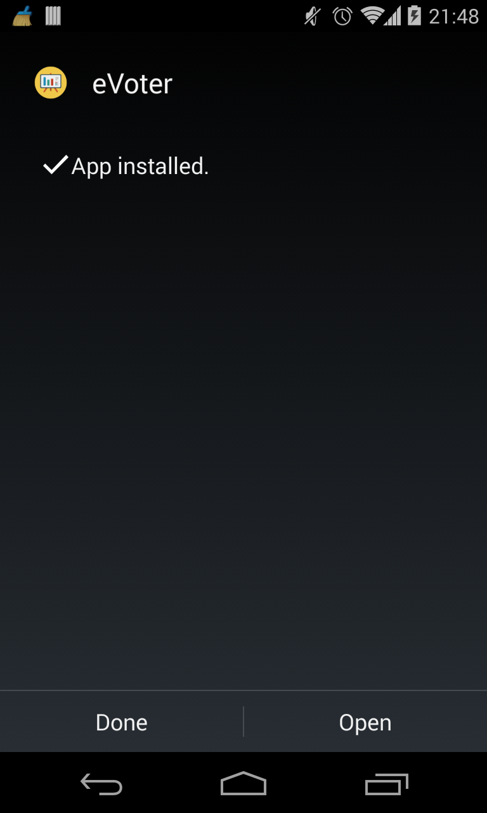/s/s6z0s55t6h5oz6n/eVoterMobile.apk](https://www.dropbox.com/s/s6z0s55t6h5oz6n/eVoterMobile.apk)

Download and install eVoterMobile

## 3.1 Login

Login eVoterMobile

To Login eVoterMobile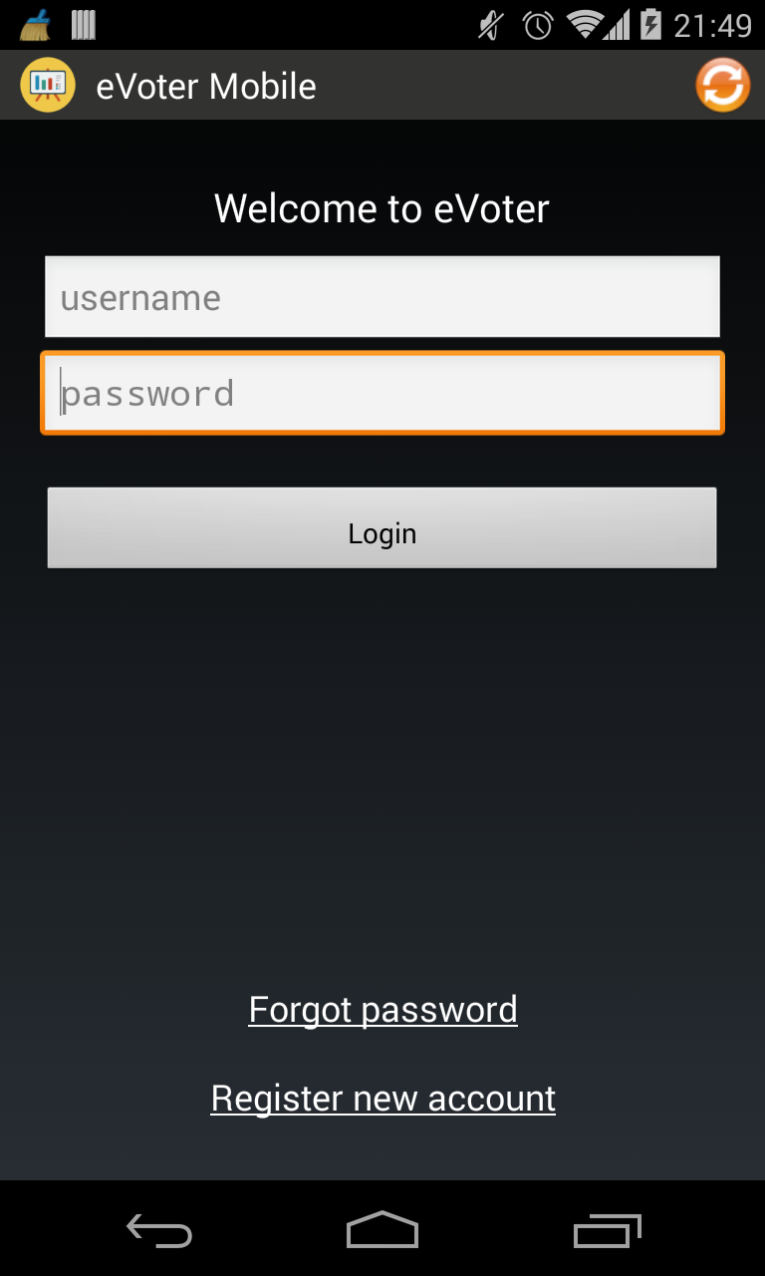, user have to have an account in eVoter System.

If user already login in eVoterMobile before, eVoterMobile will skip this screen and move on to list subject screen

## 3.2 Register

User only can register a student account from eVoterMobile.

Register new account

### 3.2.1 Valid input data

Before send request to server, eVoter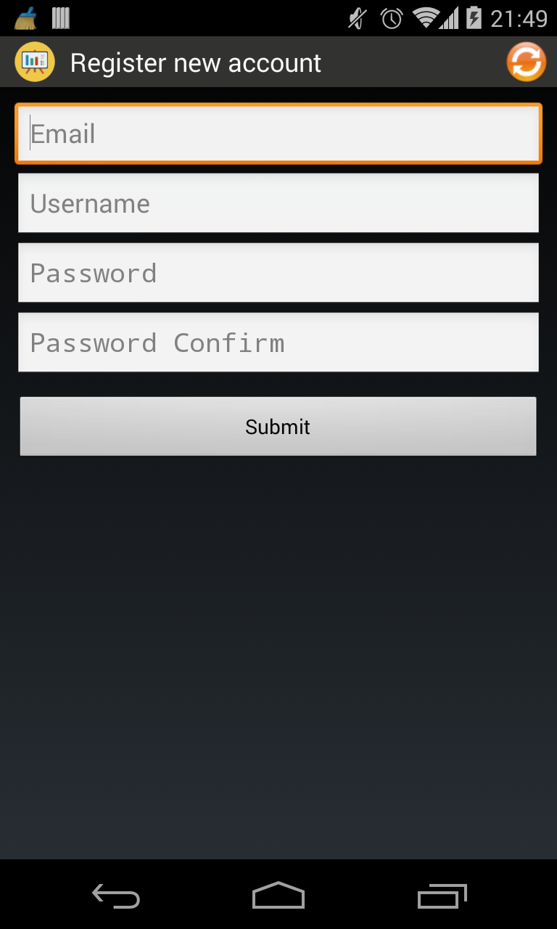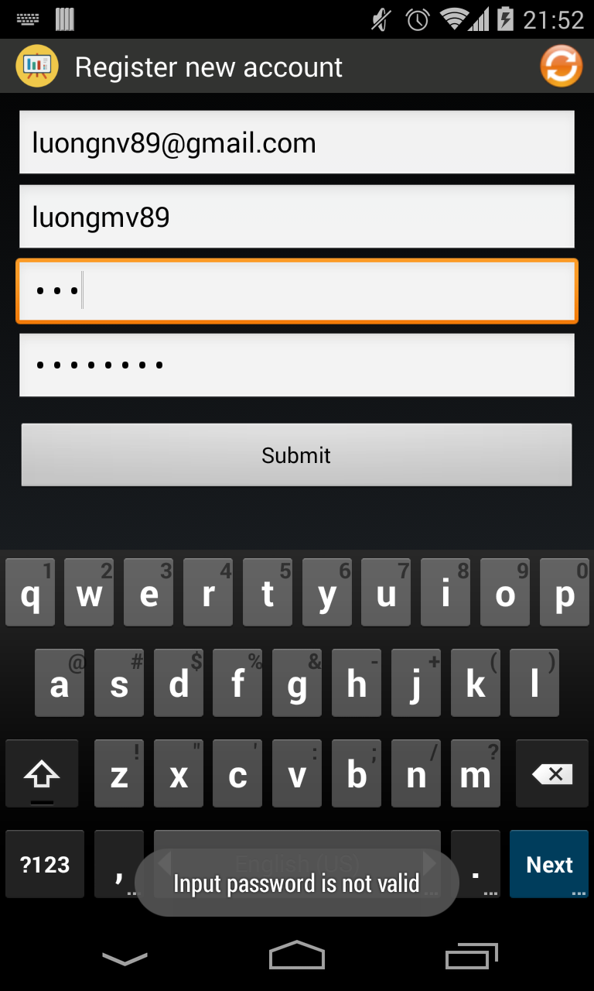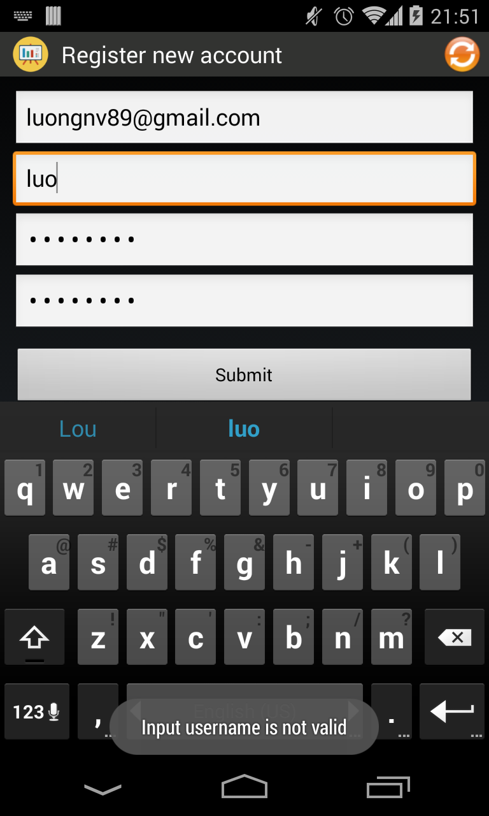 will check validation of input data.

### 3.2.2 User exists

Each user has email and username is specify. User c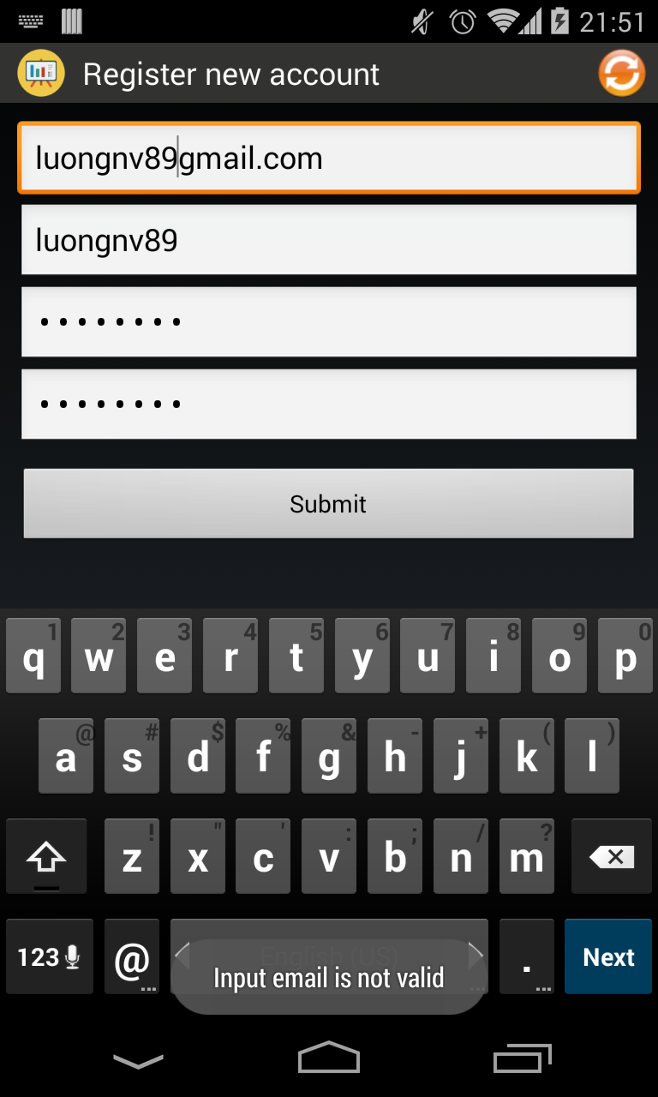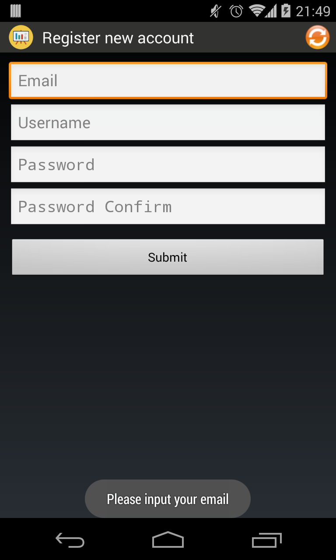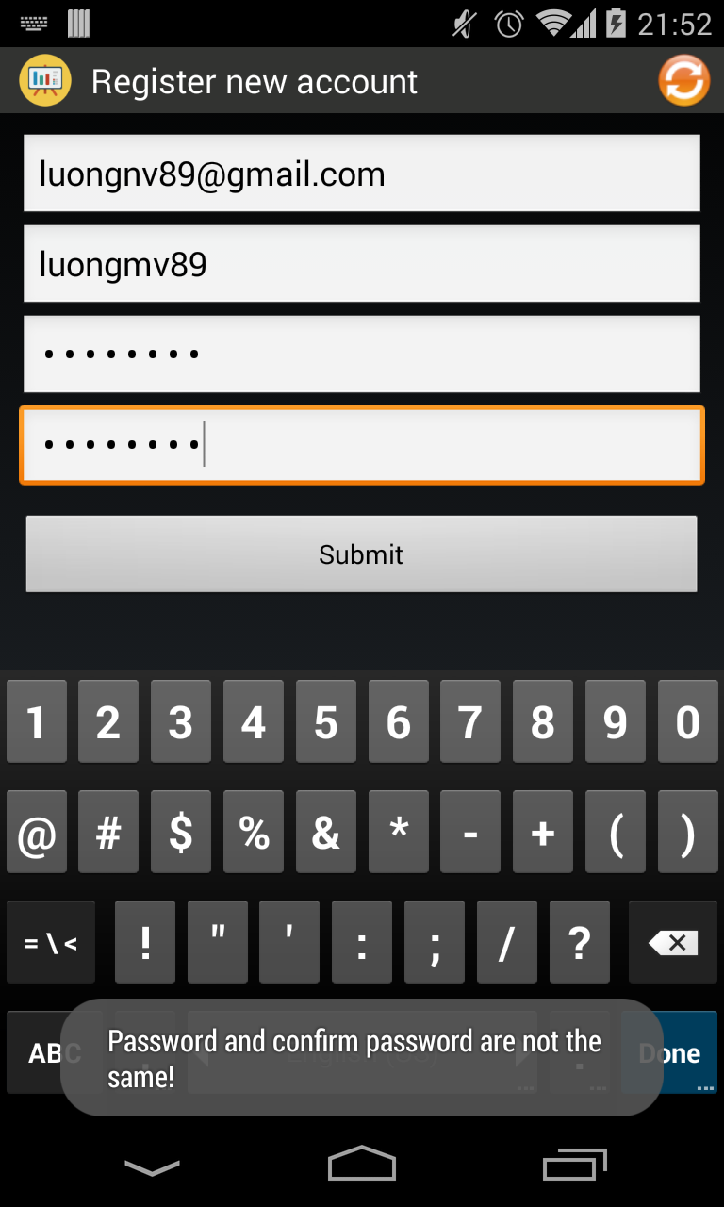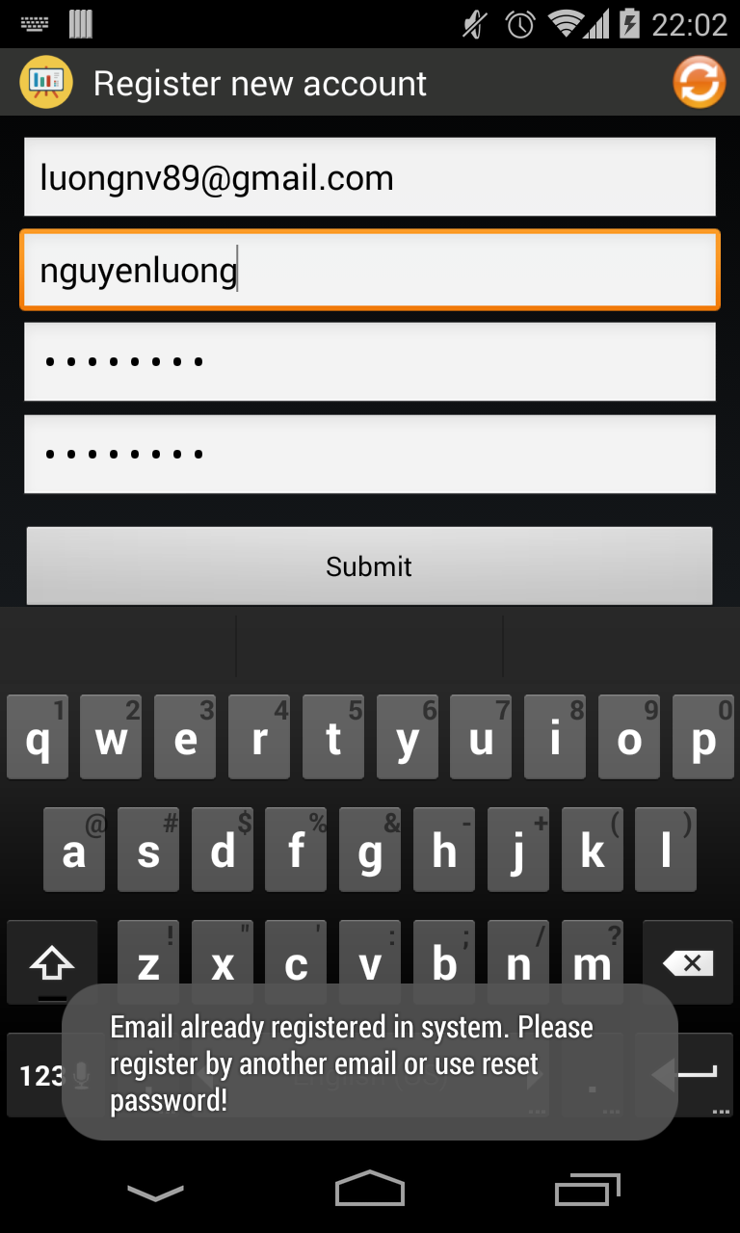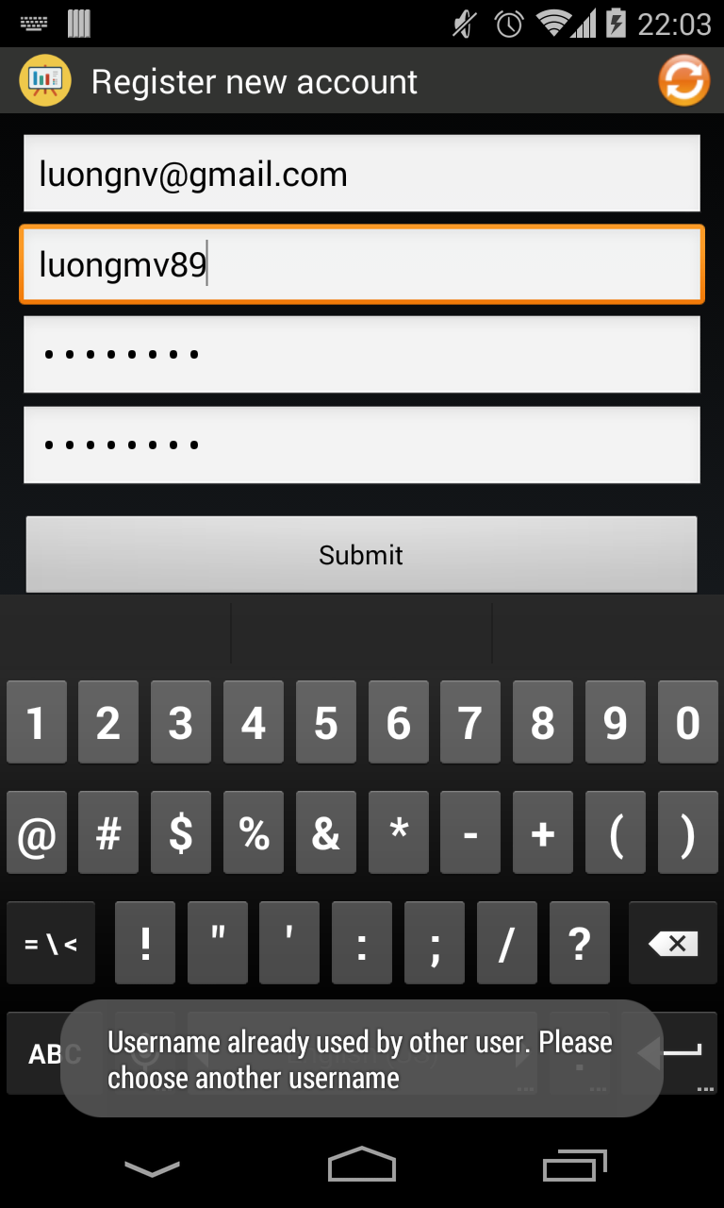annot use an email or an username to register two different account.

### 3.2.3 Register successfully

After register successfully, the username of user will be filled in username of l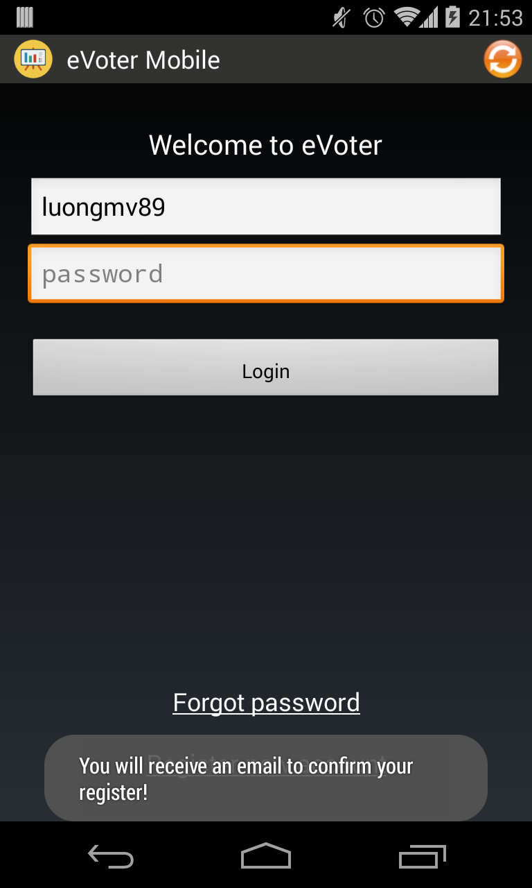ogin screen.

### 3.3. Reset password

If user forgot password, user can reset their password from eVoterMobile.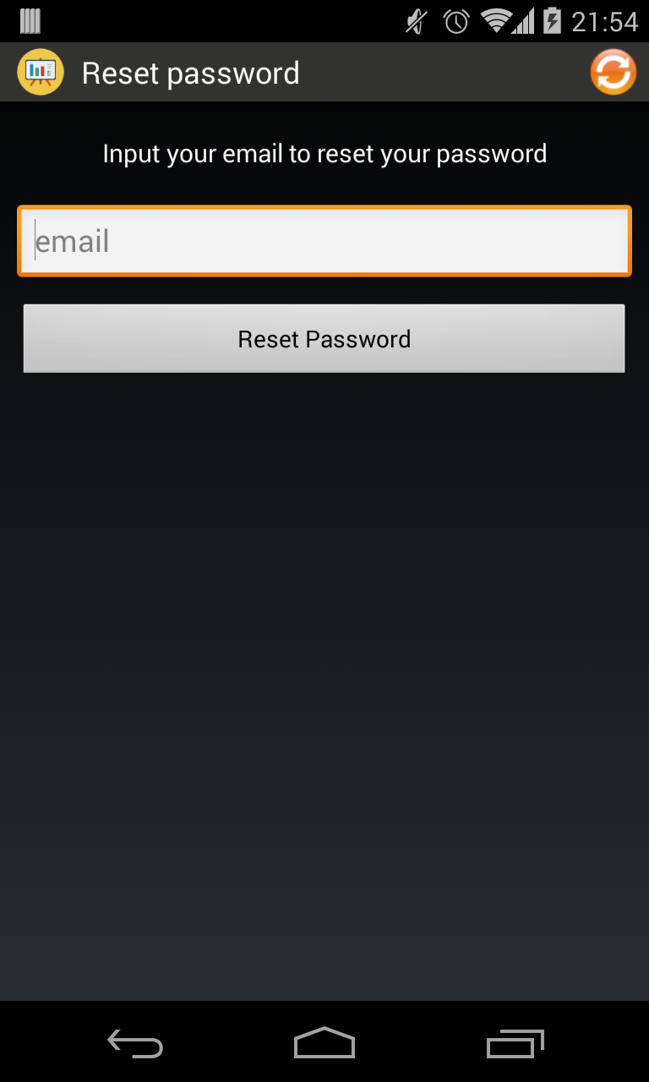

### 3.3.1 Request reset password

User has to give correct format of email and the email has to exists in eVoterSystem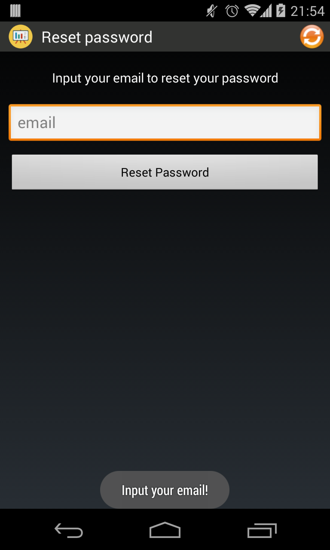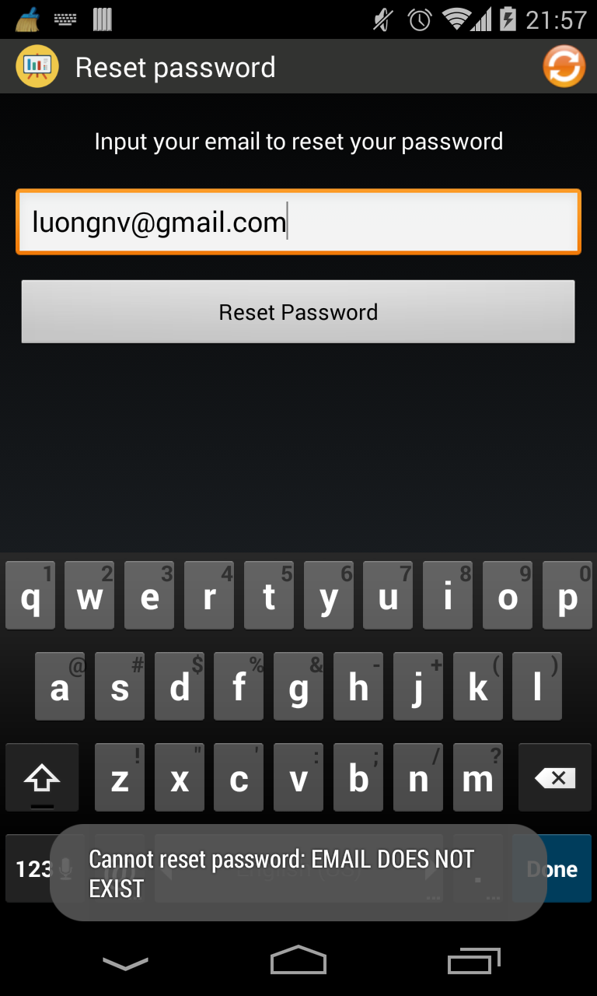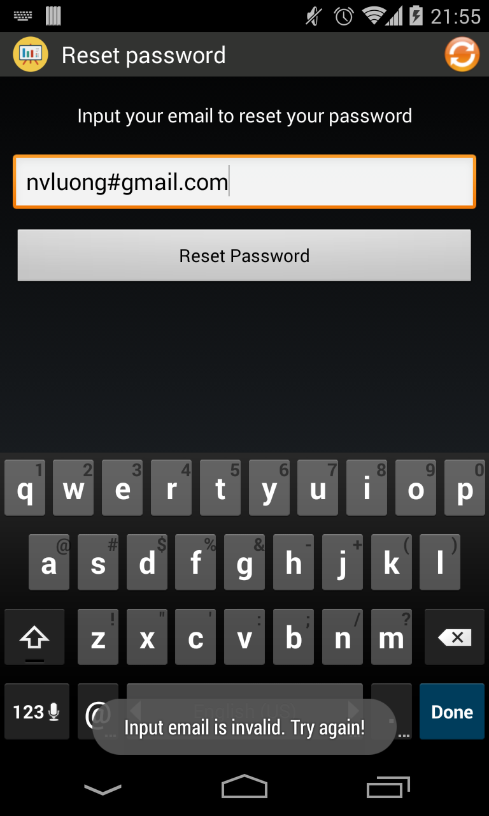

## 3.3.2 Reset password successful

If user reset password successfully, eVoterMobile will redirect to Login screen.

# 4.0 Using the eVoterMobile

## 4.1 List subject

After login successfully, eVoterMobile will show all subjects of user. The tile bar of application is the username of user.

In this screen, user can:

* Find subject by put some keyword in search 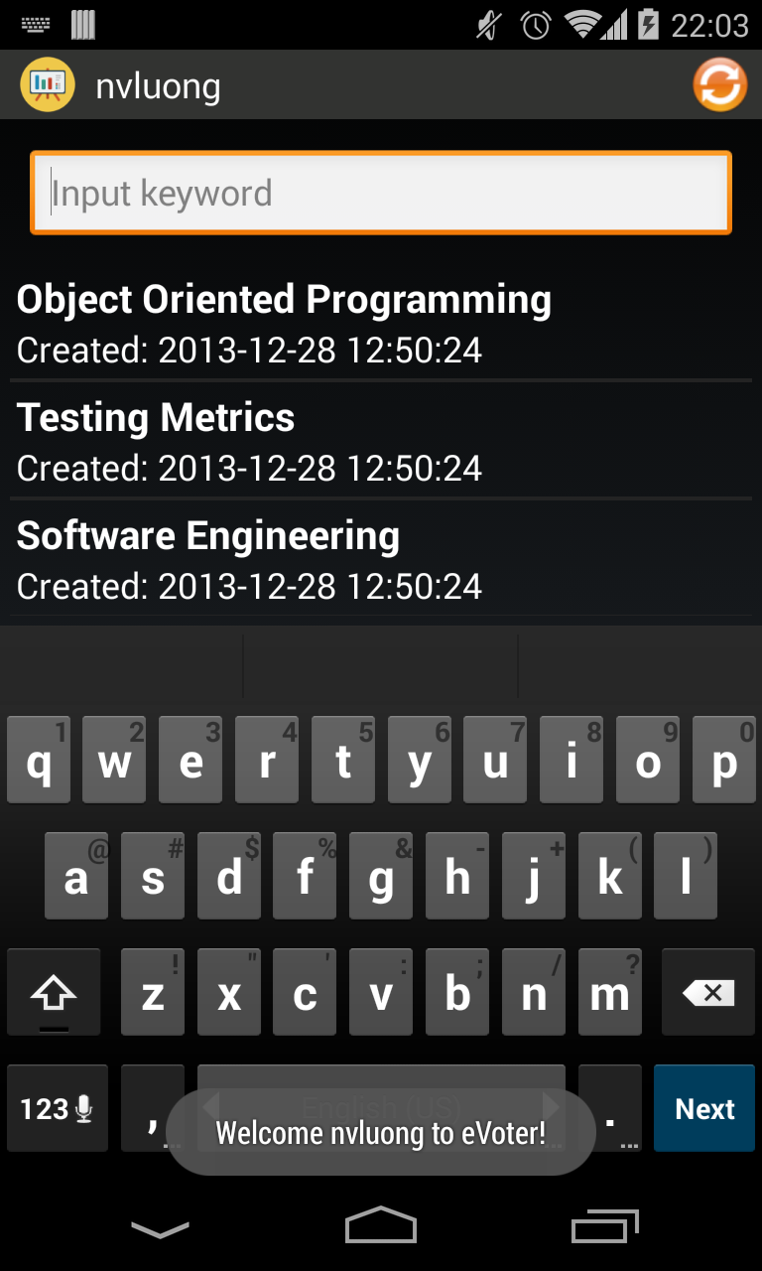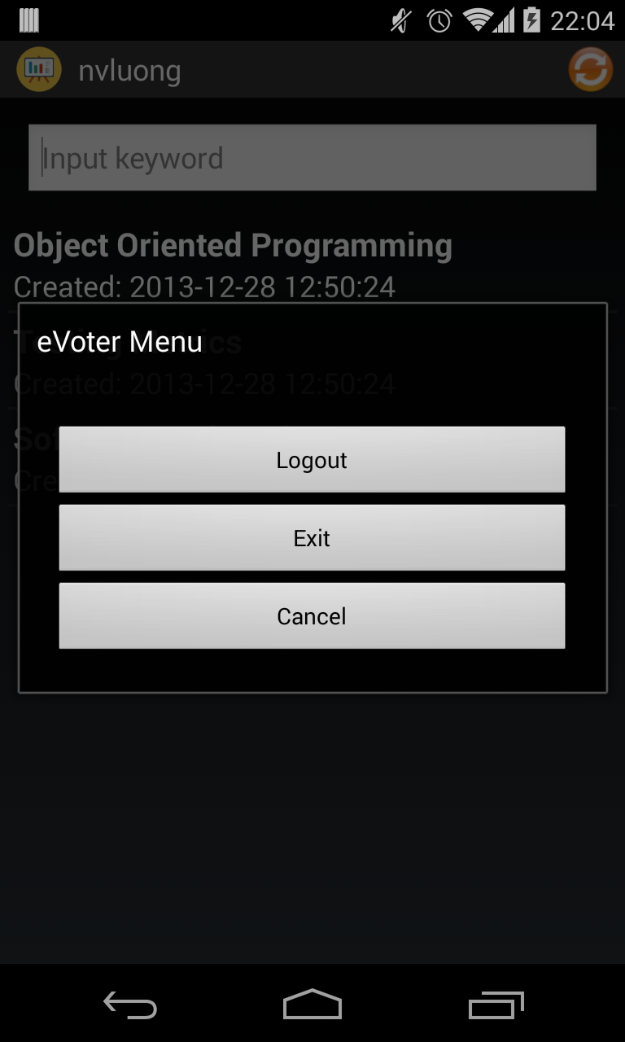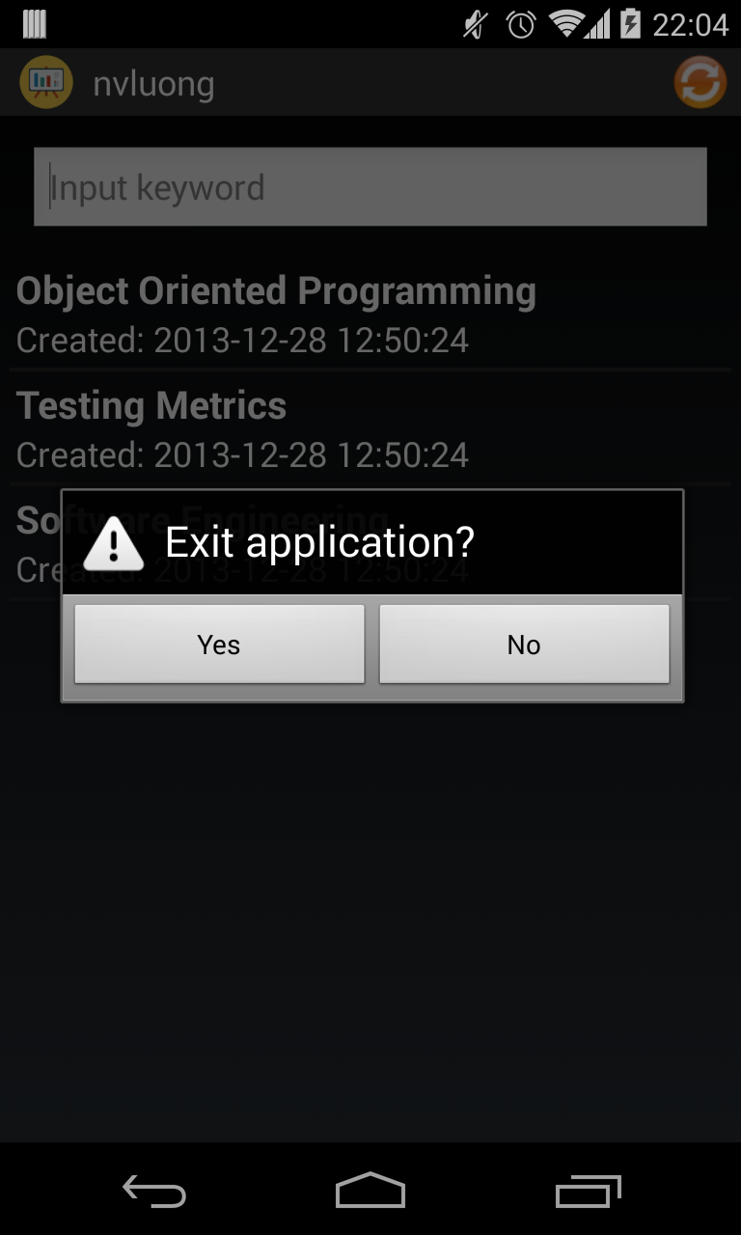box
* Refresh list subject by click on icon which is in top-left of application.
* Show main menu by click on icon which is in top-right of application.
* Logout from main menu
* Go inside a subject by click on a subject item.
* Exit from main menu

### 4.2 List session

When user click on a subject item in List Subject screen, eVoterMobile will show all session of subject.

There is two kinds of status of session:

* active: with the status text is red. An active session is a session which is running.
* inactive: with the status text is white. An inactive session is a session which is finish or not started yet.

User can delete or edit (only teacher can edit session) a session by has long click on a session item:

In this screen, there are some different functionality between teacher user and student user:

Teacher user has one more option “New Session” from main menu for creating new session.

Both teacher and student can see who in current subject.

### 4.2 List User of Subject

User click on “User of Subject” option from main menu

Show all teacher 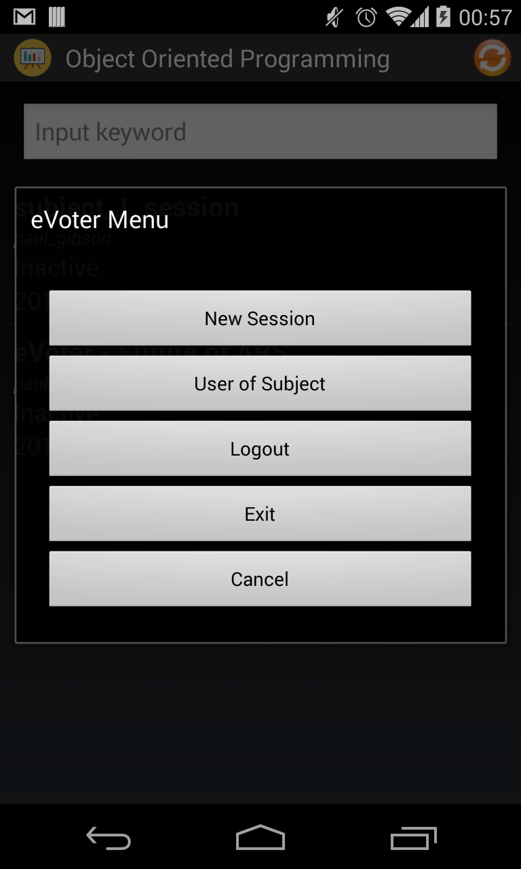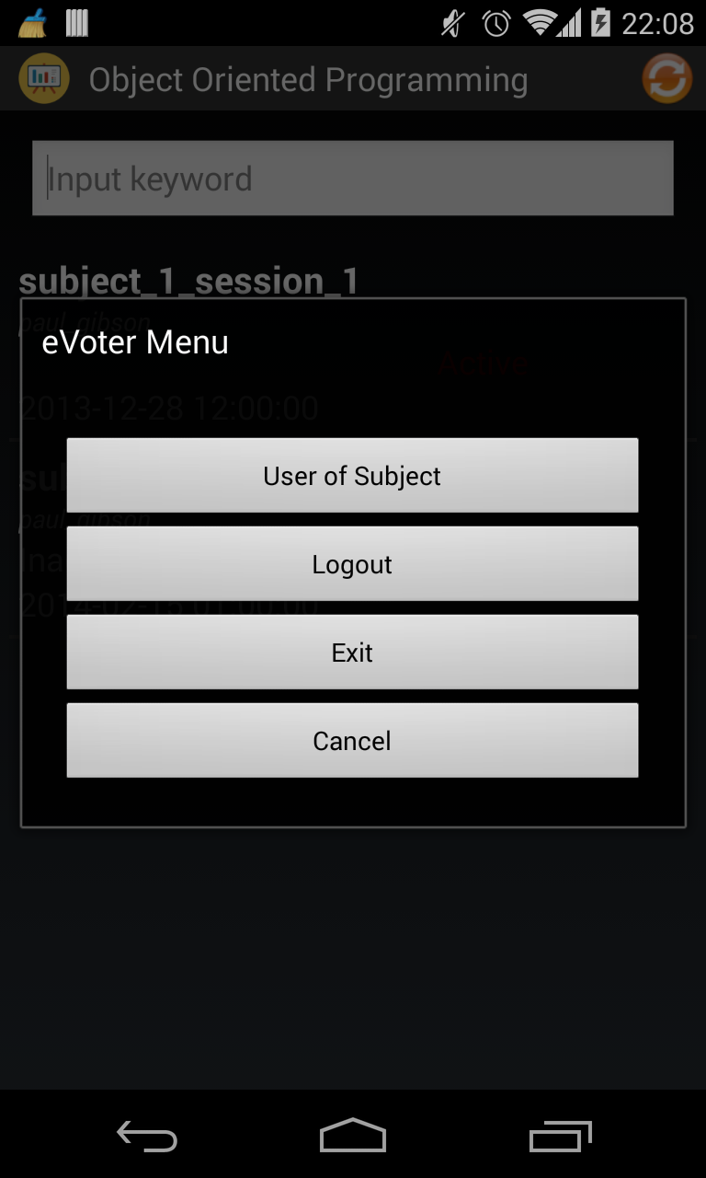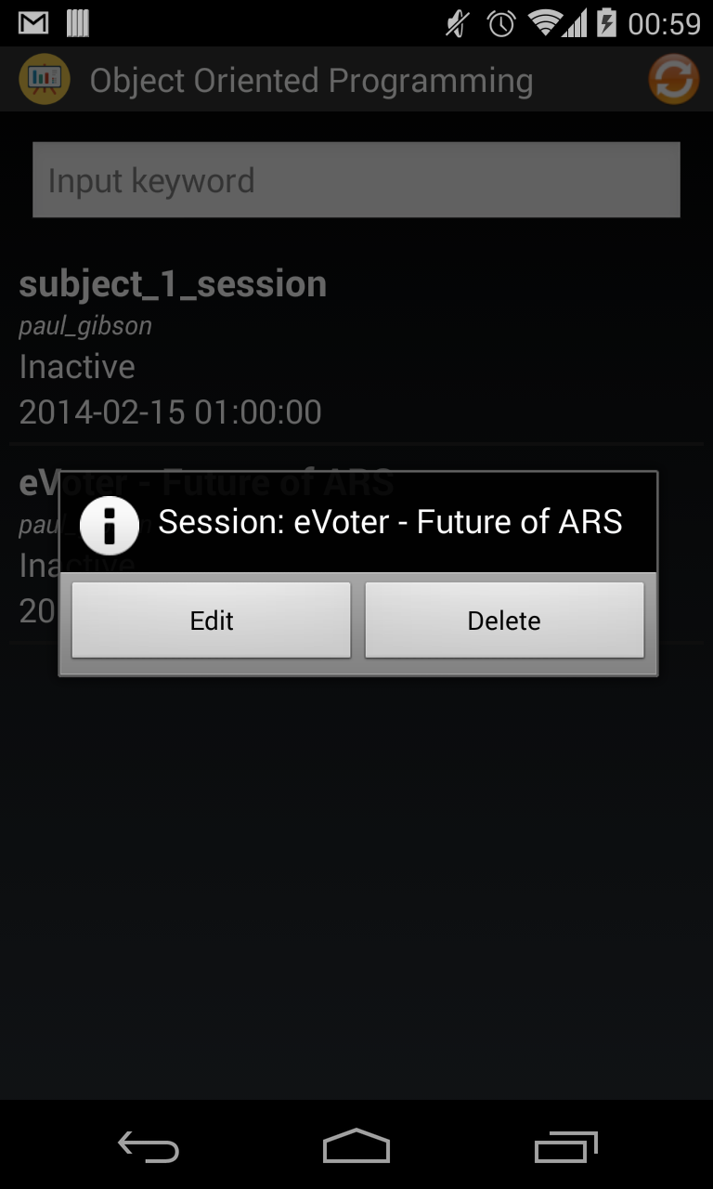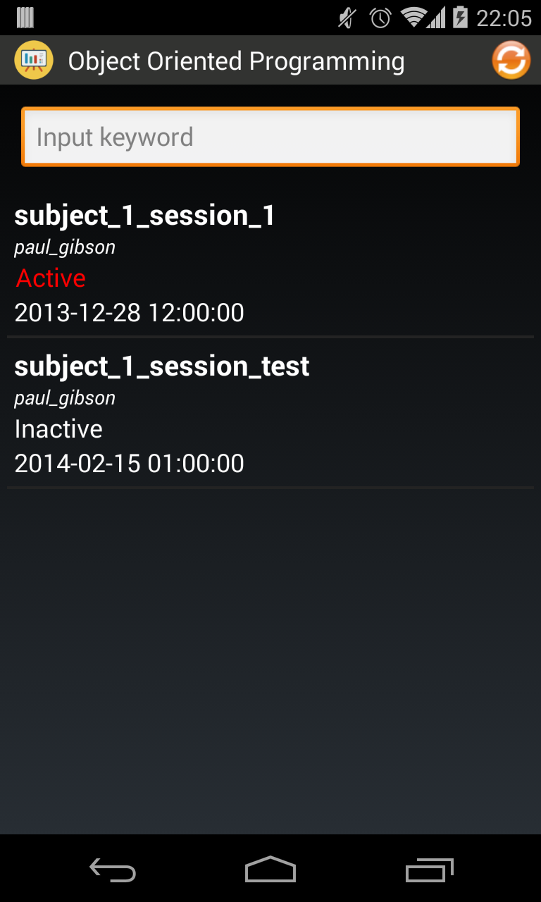and student who is in current subject:

Teacher main menu

Student main menu

### 4.3. New Session

- Only teacher can create new session.

* When teacher click on “New Session” from main menu

Only title of session is created. To create question of session, teacher has to go into session.

After new session is created, all user of current subject can join to sessi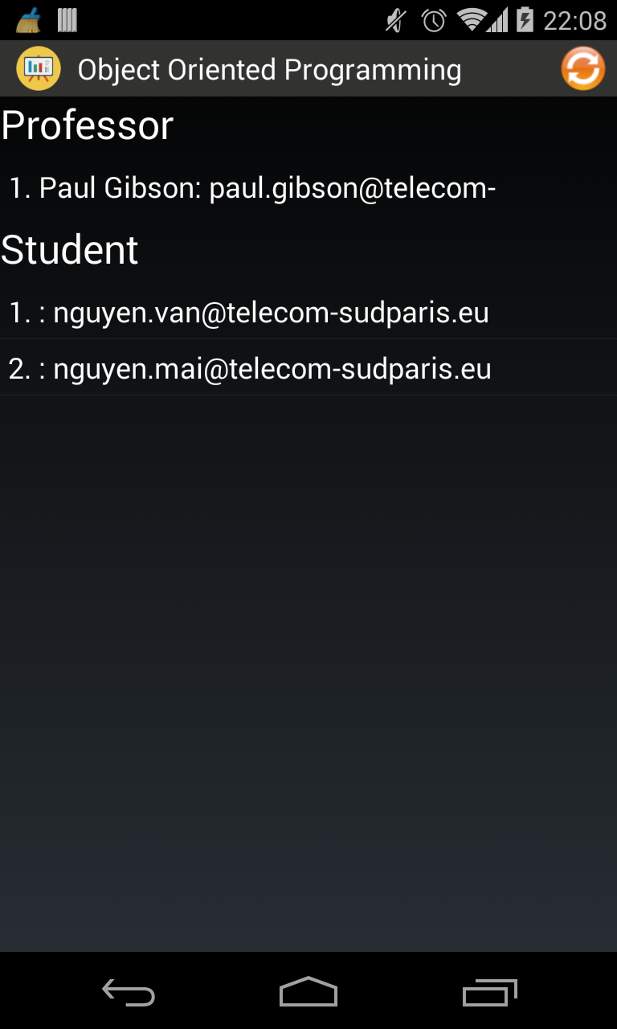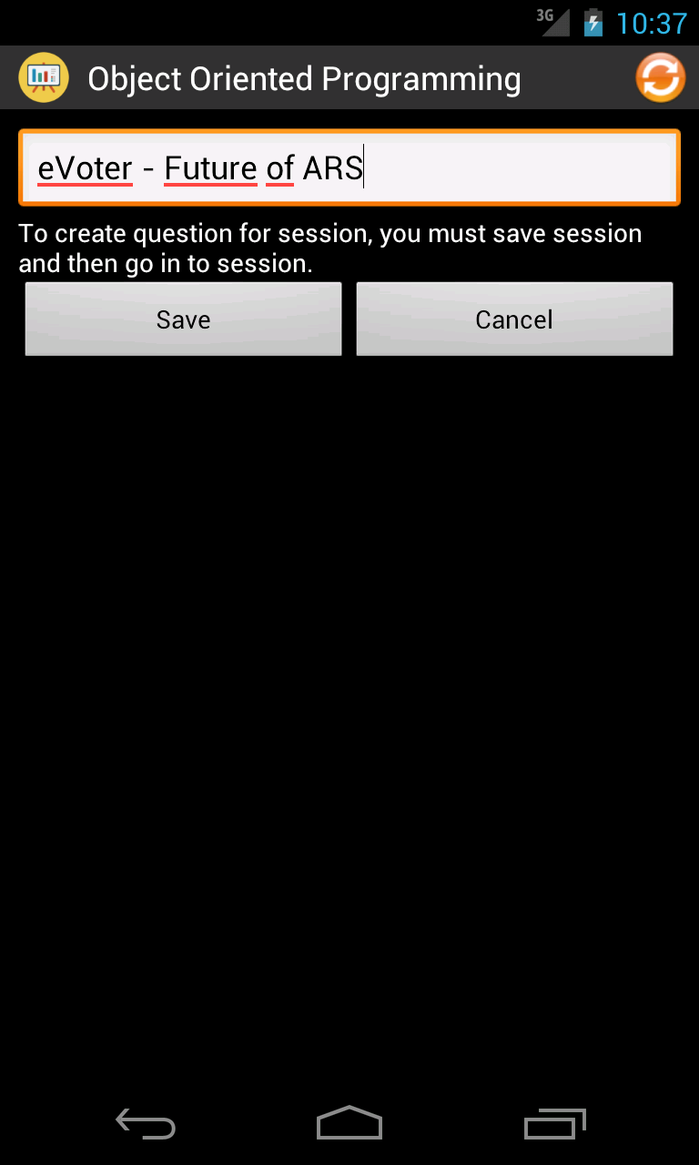on.

### 4.1.3 View detail a subject

Click button View, the “View subject” window appears with detail information of this subject.

You cannot edit any information on the window.

Close the window if you want to do other tasks.

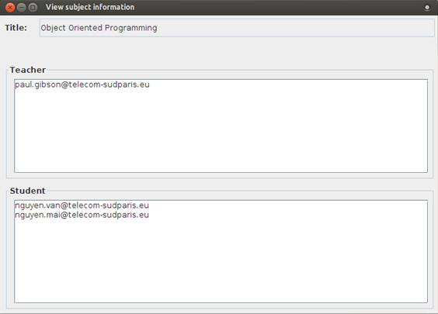

### 4.1.4 Create a new subject

Click button New Subject at the bottom, the “Add subject” window appears. You can:

* Add the title of the subject.
* Add emails of teachers by writing directly in the text field, or you can import list emails of teachers by clicking button “Import” on row of “Teacher”.
  + This field cannot be empty.
  + List of emails have to be existing teachers' emails.
  + Cannot add students' emails to this field.
* Add emails of students by writing directly in the text field, or you can import list emails of teachers by clicking button “Import” on row of “Student”.
  + This field cannot be empty.
  + List of emails have to be existing students' emails.
  + Cannot add teachers' emails to this field.
* Click button “Add” to save added information.
* If you want to cancel the task, just close the window. No subject will be created.

Click “Subject” tab on the menu bar to see the change after Add a new subject.

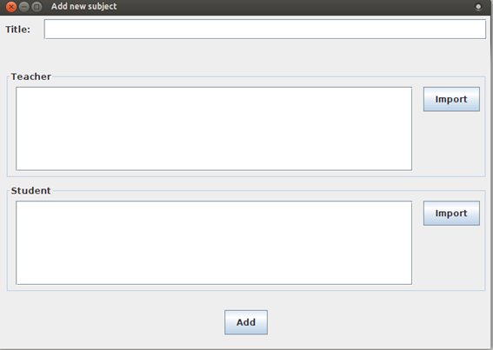

## 4.2 Teacher tab

Click on “Teacher” tab on the menu bar, the color changes from back to blue. The page will display list of all existing Teacher.

Each subject there are three buttons:

* Click button edit if you want to edit the Teacher information
* Click button delete if you want to delete the Teacher.
* Click button detail if you want to view detail about the Teacher.

### 4.2.1 Edit a teacher's information

Click button Edit, the “Edit Teacher” window appears. You can:

* Edit teacher's full name.
* Edit teacher's user name.
* Edit teacher's email.
* Click button “Update” to save edited information.
* If you don't want to “Update”, close the window or click button “Close”. Nothing will be changed.

Click “Teacher” tab on the menu bar to see the change after Edit a teacher's information.

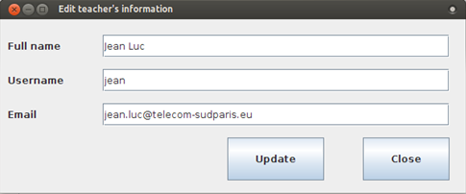

### 4.2.2 Delete a teacher

Click button Delete, a inform dialog appears to ask you to confirm your delete request.

* Click Yes, the teacher will be deleted.
* Click No, nothing changes.

Click “Teacher” tab on the menu bar to see the change after Delete a teacher.

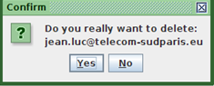

### 4.2.3 View a teacher's information

Click button View, the “View Teacher” window appears with detail information of this teacher.

You cannot edit any information on the window.

Close the window if you want to do other tasks.

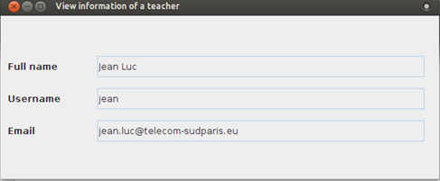

### 4.2.4 Create a new teacher

Click button New Teacher at the bottom, the “Add Teacher” window appears. You can:

* Add teacher's full name.
* Add teacher's user name.
* Add teacher's email.
* Click button “Add” to save added information.
* If you want to cancel the task, just close the window or click button Close. No teacher will be created.

Click “Teacher” tab on the menu bar to see the change after Add a new teacher.

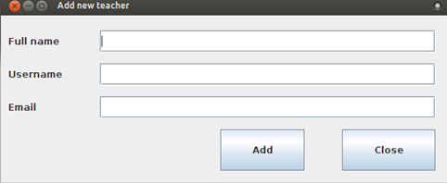

## 4.3 Student tab

Click on “Student” tab on the menu bar, the color changes from back to blue. The page will display list of all existing Student.

Each subject there are three buttons:

* Click button edit if you want to edit the Student information
* Click button delete if you want to delete the Student.
* Click button detail if you want to view detail about the Student.

### 4.3.1 Edit a student's information

Click button Edit, the “Edit Student” window appears. You can:

* Edit student's full name.
* Edit student's user name.
* Edit student's email.
* Click button “Update” to save edited information.
* If you don't want to “Update”, close the window or click button “Close”. Nothing will be changed.

Click “Student” tab on the menu bar to see the change after Edit a student's information.

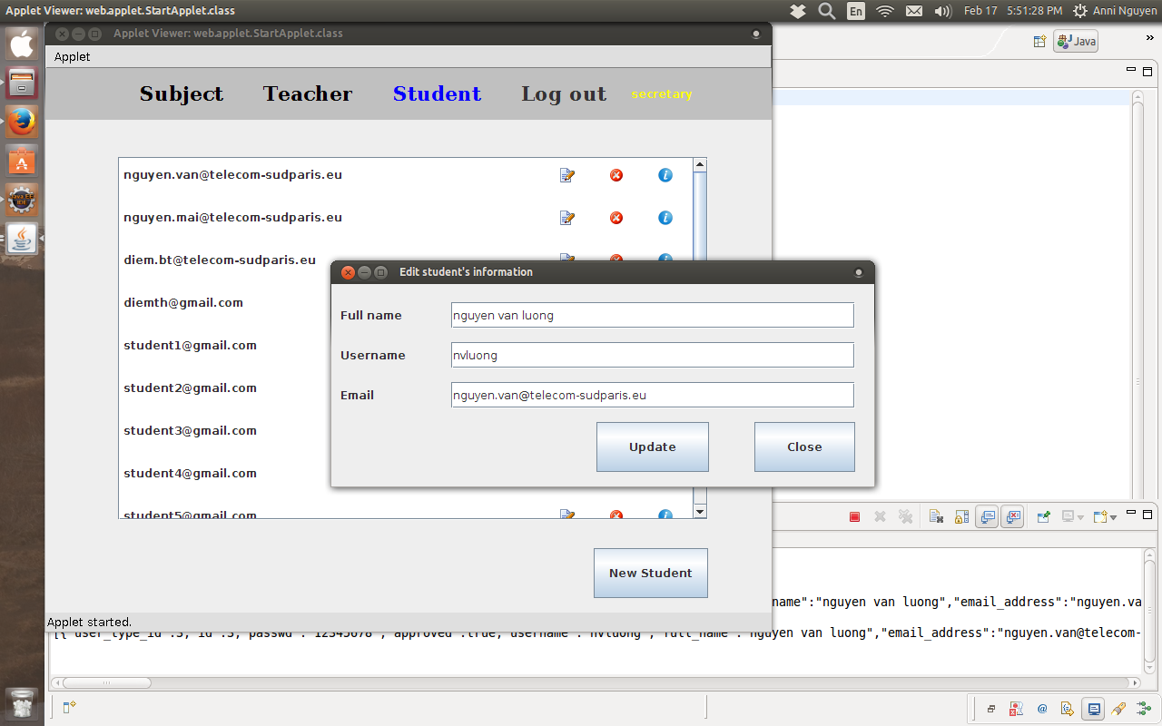

### 4.3.2 Delete a student

Click button Delete, a inform dialog appears to ask you to confirm your delete request.

* Click Yes, the student will be deleted.
* Click No, nothing changes.

Click “Student” tab on the menu bar to see the change after Delete a student.

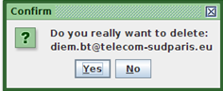

### 4.3.3 View a student's information

Click button View, the “View Student” window appears with detail information of this student.

You cannot edit any information on the window.

Close the window if you want to do other tasks.

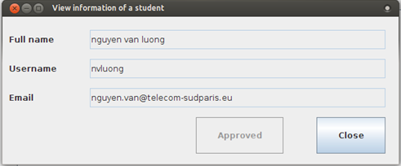

### 4.3.4 Create a new student

Click button New Teacher at the bottom, the “Add Student” window appears. You can:

* Add student's full name.
* Add student's user name.
* Add student's email.
* Click button “Add” to save added information.
* If you want to cancel the task, just close the window or click button Close. No student will be created.

Click “Student” tab on the menu bar to see the change after Add a new student.

